**Practical No. 7 & 8 : Create webpage to implement form event Part – I & II**

1. **Practical Significance:** An event is something that happens when user interact with the web page, such as when he clicked a link or button. When an event occur, you can use a JavaScript event handler (or an event listener) to detect them and perform specific task or set of tasks. By convention, the names for event handlers always begin with the word "on", so an event handler for the click event is called onclick.

### Relevant Program Outcomes (POs):

* Basic knowledge: Apply knowledge of basic mathematics, sciences and basic engineering to solve the computer group related problems.
* Discipline knowledge: Apply Computer Programming knowledge to solve the computer group related problems.
* Experiments and practice: Plan to perform experiments and practices to use the results to solve the computer group related problems.
* Engineering tools: Apply relevant Computer programming / technologies and tools with an understanding of the limitations.
* Individual and Team work: Function effectively as a leader and team member in diverse/multidisciplinary teams.
* Communication: Communicate effectively in oral and written form.

1. **Competency and Practical skills:**
2. Create a webpage to implement for event

### Relevant Course Outcome(s):

Create even based web forms using javascript.

### Practical Outcome (PrOs):

1. Create a webpage to implement form event.

### Relevant Affective domain related Outcome(s):

* 1. Follow safety practices.
  2. Practice good housekeeping
  3. Demonstrate working as a leader/ a team member.
  4. Follow ethical practices.

1. **Minimum Theoretical Background:**

|  |  |
| --- | --- |
| Object | Event Handler |
| button | *onClick, onBlur, onFocus* |
| checkbox | *onClick, onBlur, onFocus.* |
| hidden | *None* |
| password | *onBlur, onFocus, onSelect.* |
| radio | *onClick, onBlur, onFocus* |
| reset | *onReset.* |
| select | *onFocus, onBlur, onChange.* |
| submit | *onSubmit* |
| text | *onClick, onBlur, onFocus , onChange* |
| textarea | *onClick, onBlur, onFocus , onChange* |

1. **Resources required**

|  |  |  |  |  |
| --- | --- | --- | --- | --- |
| Sr. No. | Name of Resource | Broad specification | Quantity | Remark (If any) |
| 1 | Computer System | Computer (i3-i5 preferable), RAM minimum 2 GB and onwards | As per batch size | For all Experiments |
| 2 | Operating System | Windows / Linux |
| 3 | Development Software | Browser and Notepad/any Text Editor  Free Webpage Designing Tool  Any IDE |

1. **Resources used**

| S. No. | Name of Resource | Broad Specification | Qty | Remarks (If any) |
| --- | --- | --- | --- | --- |
|  | Computer System  with broad specifications | Intel Core –i5  RAM – 8 GB | 1 PC / Student |  |
|  | Operating System | Windows 10 |  |
|  | Development Software | MicromediaDreamviewer 8 |  |

1. **Result**

**_________________________________________________________________________________________________________________________________________________________________________________________________________________________________________________________________________________________________________________________________________________________**

1. **Conclusion**

**____________________________________________________________________________________________________________________________________________________________________________________________________________________________________________________________________________________**

|  |  |  |  |
| --- | --- | --- | --- |
| Marks Obtained | | | Dated Signature of Teacher |
| Process Related ( 10 ) | Product Related ( 15) | Total ( 25 ) |  |
|  |  |  |

Sample Form

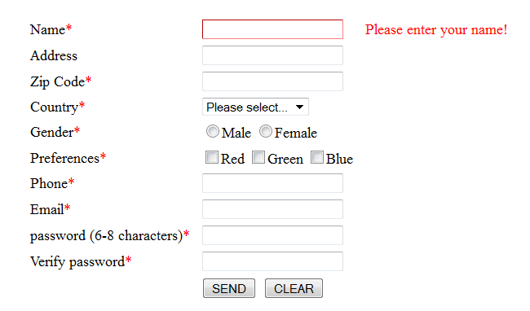

Zip code – Number (onblur)

Email – should contain @ sign (onblur)

Password – not less than 6 characters (on blur)

Verify the password matching or not

* fields should not be empty (onblur of each field)

Clear (onreset)

Onsubmit( Show the information in detail)